QIDPCA
DPCA J21 0002-2009
SPECIFICATION DE CONCEPTION DES
EMBALlAGES
PIECES
2009-08-30
2009
08-
30

I
|

DPCA J21 0002-2009
:
OR: 2009/08/30

YυYu

DPLD/CCO/1NG

HAO Jianming

DPLD/CCO/lNG

GE Biao
DEPAlDVHUSVH/REN

X1AO Liping
DEPAlDVHUSVH

444444415555555662666667773777777788889
UUMMMW
l
DPCA J21 0002-2009
l tL
H"Uu
.
11122223333344455"7777777999399mm
OR: 2009/08/30
II

DPCA J21 0002-2009
|
IJ
20098
OR: 2009/08/30
III

|
DPCA J21 0002-2009

|
OR
OR : 2009/08/30
IV

(
1
2
(
GB
3181
GSB 05-1426
3
3.1
3.2
3.3
3.4
OR: 2009/08/30

DPCA J21 0002-2009
|
3.5
3.6
4
4.1
-
4.2
:
4.3
12
'
2
OR: 2009/08/30
2

D
4

2
4

-
<1000mm

Z

P

E

1000mm

Z

-

P

E

DPCA J21 0002-2009
|
4.4
3
3
4.5
4.5.1
5
200
(
300mmX200mmX
.
..
114mm
..
..
..
.
...
4.5.2
1
..
..
..
4.5.3
5
.
.
...
..
..
.
4.6
..
:
AE
J
A= BxC+D
:
A-:

B -:/
:
:
C
:
D -
:/
5
5.1
OR : 2009/08/30
3

1000kg
:1J1l
650kg

500kg

300mmx200mmX 114mm 20kg 15kg

l
5.2
5.2.1 300mm x 200mm x 114mm1200mmx1000 mm
400mm320mmo
x 200mm x 114mm20 kg
(300mm
5.2.215 kg
5. 2. 35
5.2.4GB3181803;DPCA
5.3
5.3.1
5.3. 2 DPCA
:1000500
.
5.4
45
4
OR: 2009/08/30
4

Mm

Mm

mm

kg
l
kg
Z6432

600X40Q X 314
564 X 364 X 283
93
3.22
15
Z6422

600 X 400 X 214
564 X 364 X 183
68
2.59
15
Z4322

400X300 X 214
364 X 264 X 183
93
1.65
15
P6422

600X 400 X 214
554 X 364 X 183

2.38
15
P4322

400 X 300 X 214
362 X 265 X 183

1.44
15
P43 2

400 X 300 X 114
362 X 264 X 83

0.86
15
P3212

300X200X 114
260 X 160 X 98

0.52
20
P1042

1000 X 400 X214
950 X 360 X 183

3.25
15

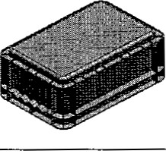
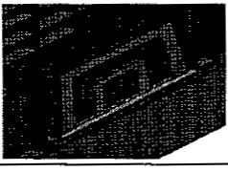
I DPCA J
|

0002-2009
5
300mmX200mm
400mm X300mm
600mmX400mm
1000mm X400mm
..ai
•
:
3mm ;
:14mm ;
12mmX20mm
:
5.5
6.
6
5.6
5.6.1
40mm
OR: 2009/08/30
5

( ) mm

( )mm

P6415
600X40DX148
P1253
1200X500X280

.
P1242
1200X400X230
P8628
800X600X280
P1043
1000X400X280
P8612
800X600X120

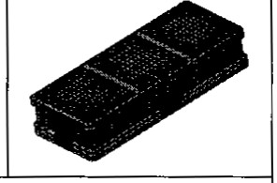

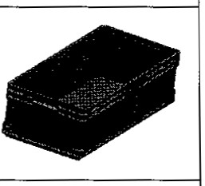

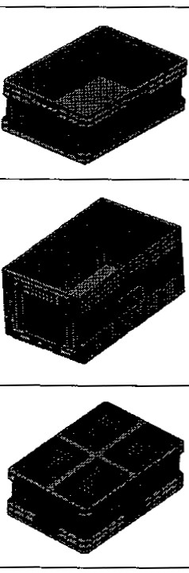

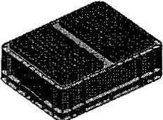

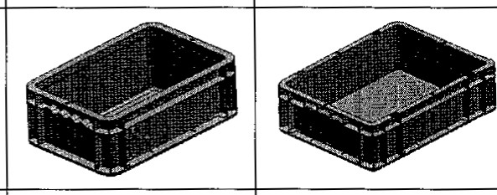

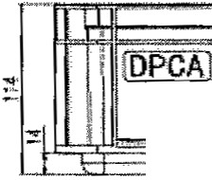
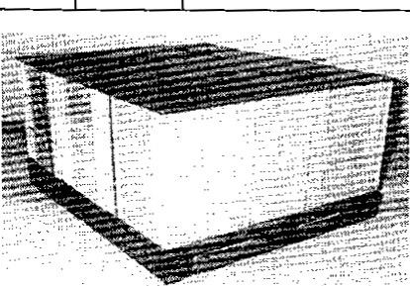
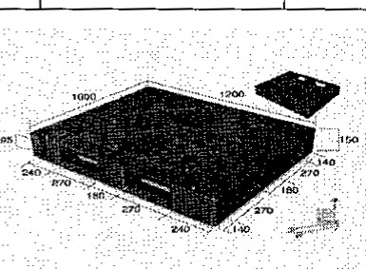
5.6.2
20mm1
1
5.6.3
6
6.1
7.
7
I
I
OR : 2009/08/30
6

kg

kg

kg

Mm

P1201
1200X100QX150
13.5
1000
4000
4 o

P 204
1210X1010X25
5
1000

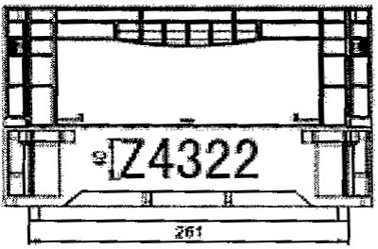

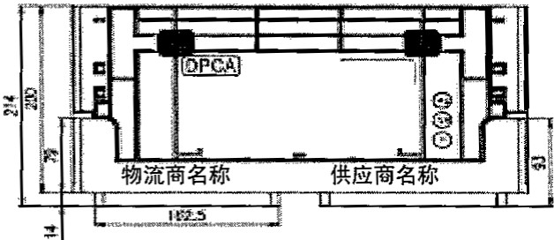

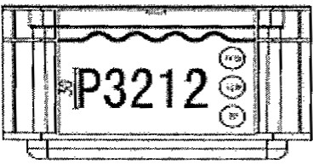

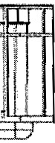

l
DPCA J21 0002-2009
6.2
6.2.1
-
-
6.2.2
1100mm1000kg1000kg
8
8
L
'
6.2.3
""
6.2.4
)1000kg
7
7.1
5
OR: 2009/08/30
7

mm)

kg

mm

1000X400X214
15
3
4
964
600X400X314
15
5
3
1 4
600X400X214
15
5
4
964
400X300X214
15
10
4
964
400X3α)X114
15
10
9
1064
300X20QX114
1200X400X120
20
15
20
2
9
8
1064

1050
1028
1200x400X230
15
2
4

1000X400X280
15
3
- . -

3
962

|
DPCA J21 0002-2009
7.2
92
9
2
7. 3
DPCA
10.
10
: z 6"
. 250mm
|
'--
-
8
OR: 2009/08/30

(mm)

(

1150 X 1 o
1600 X 1150
1950 X 1150

2300 X 1600

780
1150

1350

:
;

:

)

: 750 Kg

220 I

(

Mm

Mm

1

kg

kg
E1216
1200 X 1000 X 590
42
280
1000
4 o
E1218
1200 X 1000 X 780
42
280
1000
4000
E1616
1600 X 1150 X 590
42
280
1000
4000
E1618
1600 X 1150 X 780
42
280
1000
4000
E2318
2300 X 1600 X 780
70
300
1000
4000
E1918
1950 X 1150 X 780
42
280
1000
4000
E1611
16oo X 1 50 X 1150
42
350
1000
4000
E2311
2300 X 1600X 1150
70
300

1000
4000

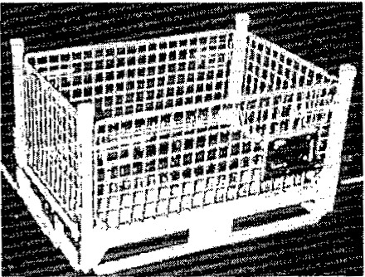

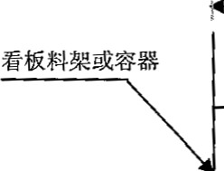

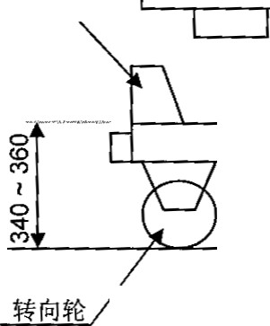
!
7.4
CGSB 05-1426-2001 32/G04 ) ;

481Y06)

6/PB05);
CGSB
05-1426-2001

05-1426-2001
:CGSB

DPCA
7.5

7.5.1
() :
1620 mmX1200mm1220mmX1020 mm
7.5.2
3mm
750
3
1300mm
1
3
7.5.3
650kg
7.6
(X|
250 mm X 150mm
OR: 2009/08/30
9



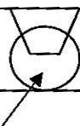

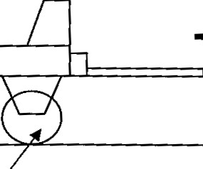



DPCA J21 0002-2009
|
50mm

4
(
4
8

8.1
(
8.2
8.2.1
8.2.2
8.3
(
9
OR: 2009/08/30
10

